Internal Assessment Resource
Agricultural and Horticultural Science Level 1
EXPIRED
This resource supports assessment against:
Achievement Standard 90922 version 2
Design a landscape plan that reflects user requirements
Resource title: School makeover
3 credits
This resource:
- Clarifies the requirements of the standard
- Supports good assessment practice
- Should be subjected to the school’s usual assessment quality assurance process
- Should be modified to make the context relevant to students in their school environment and ensure that submitted evidence is authentic

Date version published by Ministry of Education | February 2015 Version 3  To support internal assessment from 2015
Quality assurance status | These materials have been quality assured by NZQA.  NZQA Approved number A-A-02-2015-90922-02-4363
Authenticity of evidence | Teachers must manage authenticity for any assessment from a public source, because students may have access to the assessment schedule or student exemplar material.  Using this assessment resource without modification may mean that students’ work is not authentic. The teacher may need to change figures, measurements or data sources or set a different context or topic to be investigated or a different text to read or perform.

Internal Assessment Resource
Achievement Standard Agricultural and Horticultural Science 90922: Design a landscape plan that reflects user requirements
Resource reference: Agricultural and Horticultural Science 1.8B v3
Resource title: School makeover
Credits: 3
Teacher guidelines
The following guidelines are supplied to enable teachers to carry out valid and consistent assessment using this internal assessment resource.
Teachers need to be very familiar with the outcome being assessed by Achievement Standard Agricultural and Horticultural Science 90922. The achievement criteria and the explanatory notes contain information, definitions, and requirements that are crucial when interpreting the standard and assessing students against it.
Context/setting
This activity requires students to redesign a site within the school, so that it is enhanced to suit the requirements of the school community. They will also need to justify how the redesigned site will comprehensively meet those requirements in a functional manner.
Before the students start their design plan, the requirements of the school community need to be identified. They could be identified through a class brainstorm, or the students could survey other representatives of the school community, for example, other students and teachers, the principal, and the caretaker. The Preparatory Activity provides a list of possible requirements to consider.
Once the requirements have been identified, summarise them and provide each student with a copy of the summary. It is essential that all students begin the design activity with a common understanding of the school community’s requirements.
Conditions
Before beginning their design plan, students should have the opportunity to observe the site, so that they can make notes.
This is an open book activity. Students will complete the design plan individually in class, but they may refer to their notes and other relevant resources.
Resource requirements
A suitable site in the school grounds – the site should be large enough to allow students the opportunity to include a range of hard and soft landscape features in their design.
For each student:
- an outline plan of the current site
- an A3-sized redesign sheet
- a summary of the school community’s requirements for the site, as identified by the class
- a copy of Resource 1.
Additional information
None.

Internal Assessment Resource
Achievement Standard Agricultural and Horticultural Science 90922: Design a landscape plan that reflects user requirements
Resource reference: Agricultural and Horticultural Science 1.8B v3
Resource title: School makeover
Credits: 3
Achievement | Achievement with Merit | Achievement with Excellence
Design a landscape plan that reflects user requirements. | Design a landscape plan that meets user requirements. | Design a landscape plan that comprehensively meets user requirements.
Student instructions
Introduction
This assessment activity requires you to draw a designed landscape plan for a site in your school. Your plan should enhance the site, so that it meets the school community’s requirements.
You will need to justify how your plan satisfies those requirements in a functional manner. This will involve comparing and/or contrasting location and attributes of hard and soft landscape features.
This assessment is an open book activity, which means you may refer to your notes and other relevant resources as you carry out the tasks.
This is an individual assessment task.
Teacher note: Provide detail for students about the time allowed to complete each task.
Preparatory activity
This preparatory activity is not assessed.
Work as a class or in small groups to identify the community who will use the site, and list the specific requirements of this community, for example:
- access (for example, the location of paved sites and paths)
- privacy (for example, somewhere for students to work or read quietly by themselves)
- shelter (from wind and rain)
- shade (from the sun)
- aesthetics (making the site look attractive, for example, use of plants)
- recreation (for example, a site for games)
- entertainment (for example, a site for performances)
- production (for example, a site for edible gardens)
- utility (for example, a site for the ground staff to use)
- budgetary constraints (what is the budget for the project?)
Use the list of requirements you develop to guide your decision making in completing the task below.
Task
Visit the site for your landscape plan. Using your list of requirements as a guide, make notes on how you might enhance the site to meet the school community’s requirements. Consider existing landscape features and environmental factors such as sunlight and rainfall.
Draw several concept plans to develop your final design. When you are satisfied with your concepts for the site, use the A3-size design sheet provided to draw your final annotated plan. You should draw your plan to scale, and use conventional landscape symbols for hard (non-living) features and soft features (plants), such as those provided in Resource 1.
Write a detailed explanation of your plan. You must justify your design plan in relation to the requirements of the school community. Consider:
- scale
- environmental factors
- the requirements of the whole school community (staff and students)
- how the attributes of hard and soft landscaping features (such as plants, a bench seat) work individually and together to meet these requirements
- how the positioning of these hard and soft landscaping features works to meet these requirements
- how this use and positioning compares with the original site, as well as other possible alternatives.

Resource 1: Design symbols
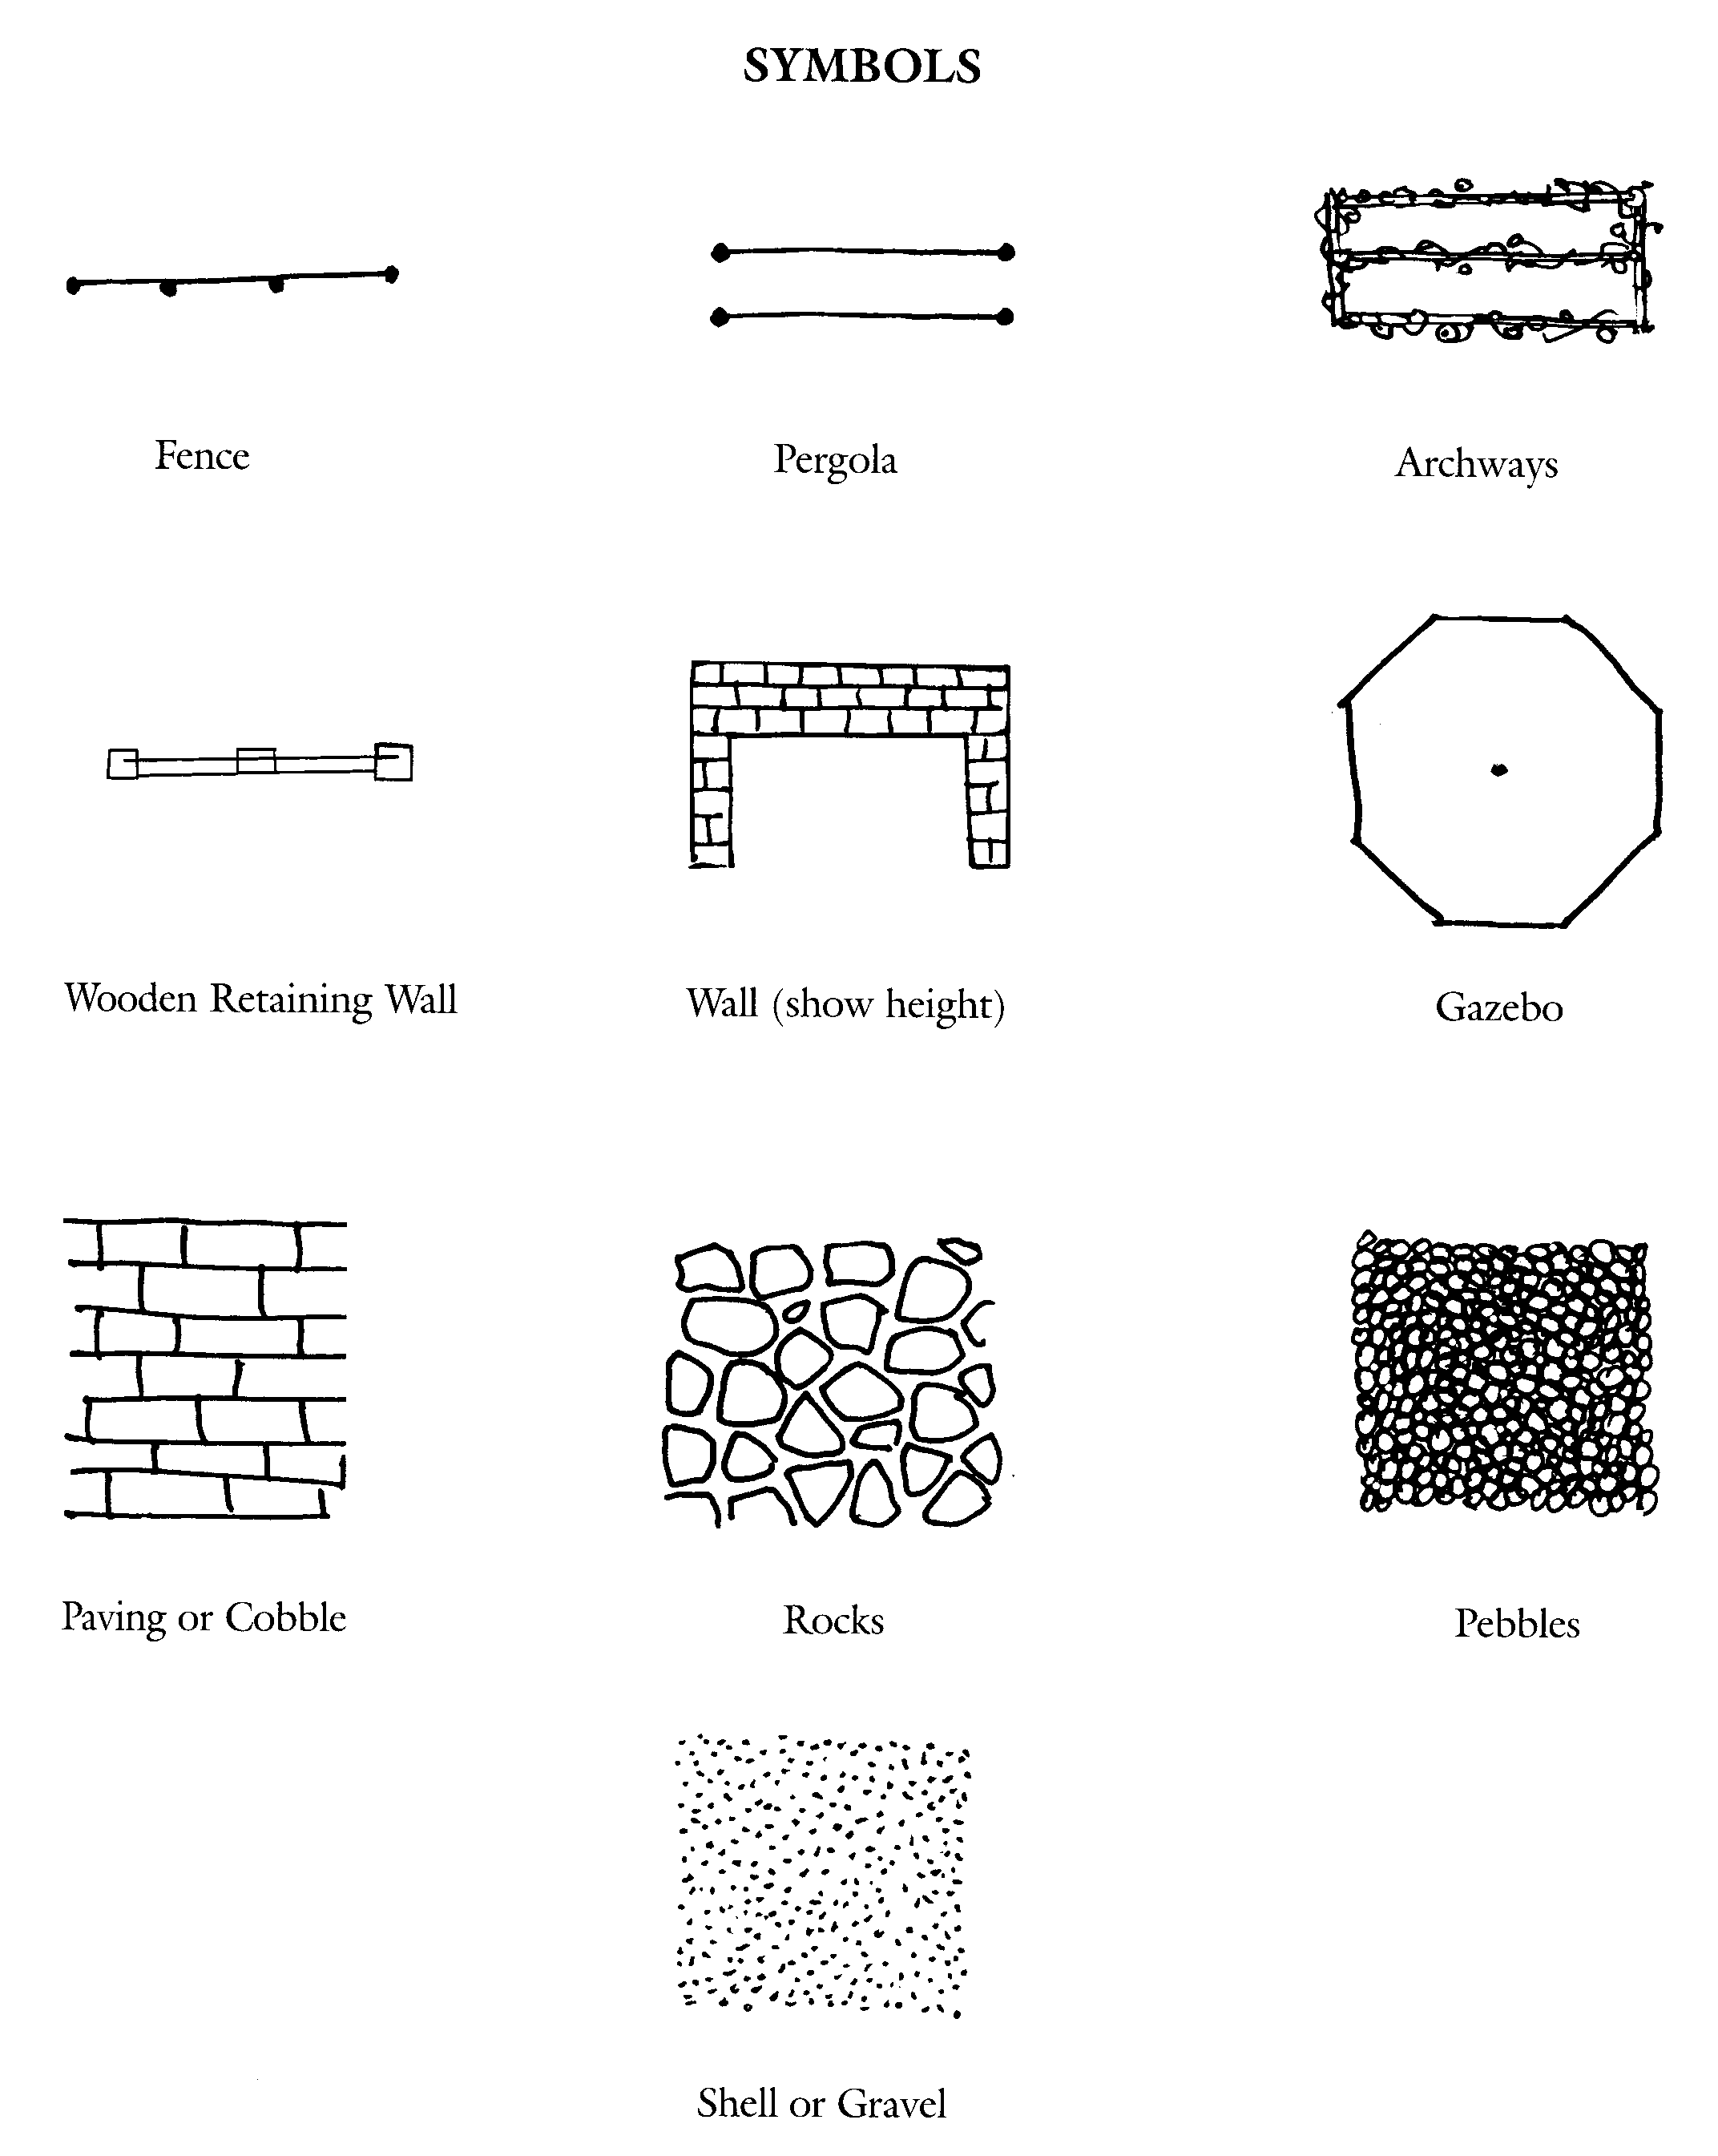 | 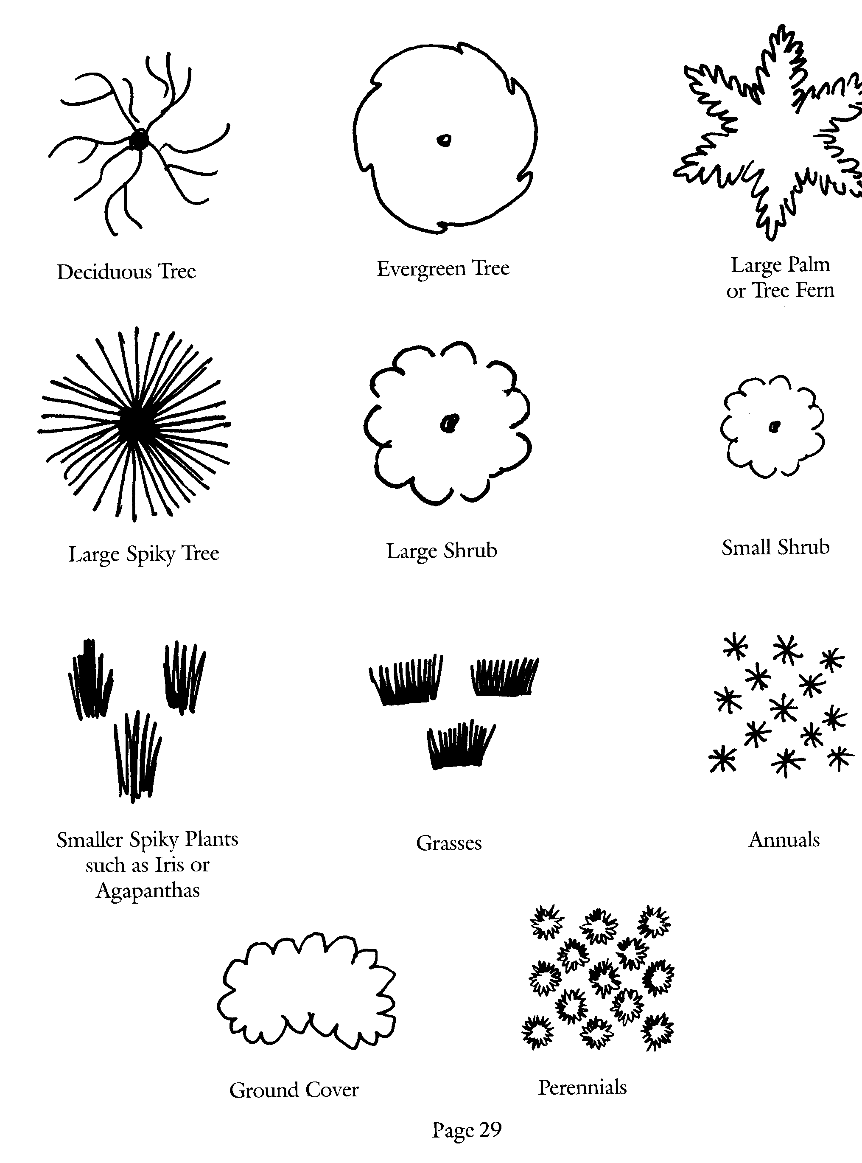
[Source: The Ellerslie Flower Show – An introduction to Garden Design]

Assessment schedule: Agricultural and Horticultural Science 90922 School makeover
Evidence/Judgements for Achievement | Evidence/Judgements for Achievement with Merit | Evidence/Judgements for Achievement with Excellence
The student produces a designed landscape plan that would enhance the site and reflect the majority of the requirements of the school community.  The plan includes a detailed drawing using labelled, conventional symbols that identify the use and position of the new features.  The student describes how the use and positioning of new features satisfies the requirements of the school community. For example:  - Significant plants/groups of plants are identified. Specific scientific names are not required, however it would be expected that students will describe the type of plant or growth habit.  - Hard features are identified, for example, paths, seats, walls, rubbish bins.  - The written notes give superficial reasons for the location of the majority of soft and hard landscaping features, but may not demonstrate functionality. For example, a student could give the following reason for the location of a feature:  The students need a path to go around the big tree. | The student produces a designed landscape plan that would enhance the site to meet the majority of the requirements of the school community in a functional manner. The student refers to links between the new features and also between the new and existing features and the impact that environmental factors have had in determining their location.  The plan includes a detailed drawing using labelled, conventional symbols that identify the use and position of the new features.  The student demonstrates by way of an explanation, the use and positioning of the majority of the new features in terms of how they meet the school community’s requirements in a functional manner. For example:  - Significant plants/groups of plants are identified. Specific scientific names are not required, however it would be expected that students will describe the type of plant or growth habit.  - Hard features are identified, for example, paths, seats, walls, rubbish bins.  - The written notes give reasons for the use and location of the majority of soft and hard landscaping features and demonstrate how the features are functional; and the impact that environmental factors have on the locations. For example, a student could give the following reason for the location of a feature:  The path around the big tree will allow students to walk from the canteen to the seats without getting muddy shoes due to the poor drainage qualities of the soil. | The student produces a designed landscape plan that would enhance the site to comprehensively meet the requirements of the school community in a functional manner. The student refers to links between the new features and also between the new and existing features and the impact that environmental factors have had in determining their location.  The plan includes a detailed drawing using labelled, conventional symbols that identify the use and position of the new features.  The student demonstrates by way of an explanation, the use and positioning of the majority of the new features in terms of how they meet the school community’s requirements in a functional manner. For example:  - Significant plants/groups of plants are identified. Specific scientific names are not required, however it would be expected that students will describe the type of plant or growth habit.  - Hard features are identified, for example, paths, seats, walls, rubbish bins.  The written notes justify the use and positioning of soft and hard landscaping features and comprehensively meet the school community’s requirements by explaining the benefits of the addition of a new feature’s position compared with either what was originally there or with other possible alternatives. This must include the consideration of scale and environmental factors.  For example, a student could give the following reason for the location of a feature:  The path around the big tree is made of paving stones with a roughened surface. This will allow students to walk from the canteen to the seats without getting muddy shoes, and it will not get too slippery on frosty mornings. This would be better than plain concrete because it is safer and looks more aesthetically pleasing.
Final grades will be decided using professional judgement based on a holistic examination of the evidence provided against the criteria in the Achievement Standard

